ALGORITHMS FOR EDGE DETECTION

SRIKANTH RANGARAJAN
105210122

INTRODUCTION TO FUNDAMENTALS OF EDGE DETECTION

Edge detection refers to the process of identifying and locating sharp discontinuities in an image. The discontinuities are abrupt changes in pixel intensity which characterize boundaries of objects in a scene. Classical methods of edge detection involve convolving the image with an operator (a 2-D filter), which is constructed to be sensitive to large gradients in the image while returning values of zero in uniform regions. There is an extremely large number of edge detection operators available, each designed to be sensitive to certain types of edges. Variables involved in the selection of an edge detection operator include:
- Edge orientation: The geometry of the operator determines a characteristic direction in which it is most sensitive to edges. Operators can be optimized to look for horizontal, vertical, or diagonal edges.

- Noise environment: Edge detection is difficult in noisy images, since both the noise and the edges contain high-frequency content. Attempts to reduce the noise result in blurred and distorted edges. Operators used on noisy images are typically larger in scope, so they can average enough data to discount localized noisy pixels. This results in less accurate localization of the detected edges.

- Edge structure: Not all edges involve a step change in intensity. Effects such as refraction or poor focus can result in objects with boundaries defined by a gradual change in intensity. The operator needs to be chosen to be responsive to such a gradual change in those cases. Newer wavelet-based techniques actually characterize the nature of the transition for each edge in order to distinguish, for example, edges associated with hair from edges associated with a face.

There are many ways to perform edge detection. However, the majority of different methods may be grouped into two categories:

- Gradient: The gradient method detects the edges by looking for the maximum and minimum in the first derivative of the image.

- Laplacian: The Laplacian method searches for zero crossings in the second derivative of the image to find edges. An edge has the one-dimensional shape of a ramp and calculating the derivative of the image can highlight its location. Suppose we have the following signal, with an edge shown by the jump in intensity below:

Suppose we have the following signal, with an edge shown by the jump in intensity below:
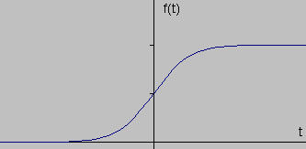
If we take the gradient of this signal (which, in one dimension, is just the first derivative with respect to t) we get the following:

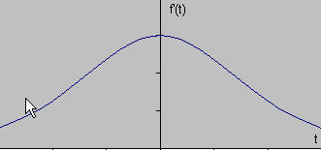

Clearly, the derivative shows a maximum located at the center of the edge in the original signal. This method of locating an edge is characteristic of the “gradient filter” family of edge detection filters and includes the Sobel method. A pixel location is declared an edge location if the value of the gradient exceeds some threshold. As mentioned before, edges will have higher pixel intensity values than those surrounding it. So once a threshold is set, you can compare the gradient value to the threshold value and detect an edge whenever the threshold is exceeded. Furthermore, when the first derivative is at a maximum, the second derivative is zero. As a result, another alternative to finding the location of an edge is to locate the zeros in the second derivative. This method is known as the Laplacian and the second derivative of the signal is shown below:

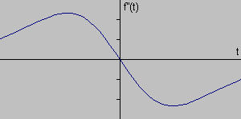

EDGE DETECTION TECHNIQUES

Sobel Operator
The operator consists of a pair of 3×3 convolution kernels as shown in Figure 1. One kernel is simply the other rotated by 90°.
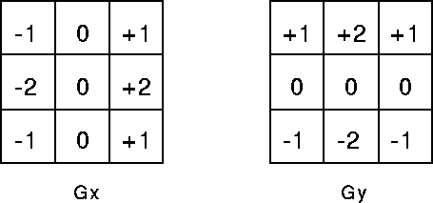
These kernels are designed to respond maximally to edges running vertically and horizontally relative to the pixel grid, one kernel for each of the two perpendicular orientations. The kernels can be applied separately to the input image, to produce separate measurements of the gradient component in each orientation (call these Gx and Gy). These can then be combined together to find the absolute magnitude of the gradient at each point and the orientation of that gradient. The gradient magnitude is given by:

Typically, an approximate magnitude is computed using:

which is much faster to compute.
The angle of orientation of the edge (relative to the pixel grid) giving rise to the spatial gradient is given by:

Robert’s cross operator:

The Roberts Cross operator performs a simple, quick to compute, 2-D spatial gradient measurement on an image. Pixel values at each point in the output represent the estimated absolute magnitude of the spatial gradient of the input image at that point.
The operator consists of a pair of 2×2 convolution kernels as shown in Figure. One kernel is simply the other rotated by 90°. This is very similar to the Sobel operator.

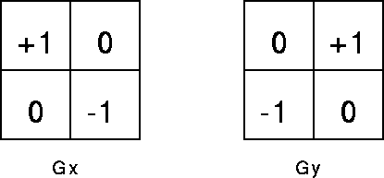
These kernels are designed to respond maximally to edges running at 45° to the pixel grid, one kernel for each of the two perpendicular orientations. The kernels can be applied separately to the input image, to produce separate measurements of the gradient component in each orientation (call these Gx and Gy). These can then be combined together to find the absolute magnitude of the gradient at each point and the orientation of that gradient. The gradient magnitude is given by:

although typically, an approximate magnitude is computed using:
which is much faster to compute.
The angle of orientation of the edge giving rise to the spatial gradient (relative to the pixel grid orientation) is given by:

Prewitt’s operator:

Prewitt operator is similar to the Sobel operator and is used for detecting vertical and horizontal edges in images.

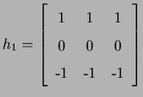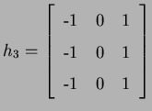

Laplacian of Gaussian:
The Laplacian is a 2-D isotropic measure of the 2nd spatial derivative of an image. The Laplacian of an image highlights regions of rapid intensity change and is therefore often used for edge detection. The Laplacian is often applied to an image that has first been smoothed with something approximating a Gaussian Smoothing filter in order to reduce its sensitivity to noise. The operator normally takes a single graylevel image as input and produces another graylevel image as output.
The Laplacian L(x,y) of an image with pixel intensity values I(x,y) is given by:
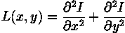
Since the input image is represented as a set of discrete pixels, we have to find a discrete convolution kernel that can approximate the second derivatives in the definition of the Laplacian. Three commonly used small kernels are shown in Figure 1.
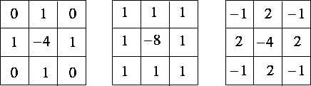
Figure 1 Three commonly used discrete approximations to the Laplacian filter.

Because these kernels are approximating a second derivative measurement on the image, they are very sensitive to noise. To counter this, the image is often Gaussian Smoothed before applying the Laplacian filter. This pre-processing step reduces the high frequency noise components prior to the differentiation step.
In fact, since the convolution operation is associative, we can convolve the Gaussian smoothing filter with the Laplacian filter first of all, and then convolve this hybrid filter with the image to achieve the required result. Doing things this way has two advantages:
- Since both the Gaussian and the Laplacian kernels are usually much smaller than the image, this method usually requires far fewer arithmetic operations.
- The LoG (`Laplacian of Gaussian') kernel can be precalculated in advance so only one convolution needs to be performed at run-time on the image.
The 2-D LoG function centered on zero and with Gaussian standard deviation has the form:
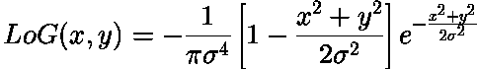
and is shown in Figure 2.

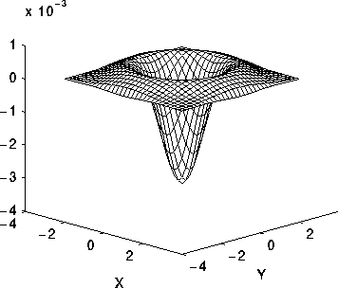

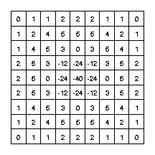

Figure 3 Discrete approximation to LoG function with Gaussian = 1.4

Note that as the Gaussian is made increasingly narrow, the LoG kernel becomes the same as the simple Laplacian kernels shown in Figure 1. This is because smoothing with a very narrow Gaussian ( < 0.5 pixels) on a discrete grid has no effect. Hence on a discrete grid, the simple Laplacian can be seen as a limiting case of the LoG for narrow Gaussians.

Canny’s Edge Detection Algorithm

The Canny edge detection algorithm is known to many as the optimal edge detector. Canny's intentions were to enhance the many edge detectors already out at the time he started his work. He was very successful in achieving his goal and his ideas and methods can be found in his paper, "A Computational Approach to Edge Detection". In his paper, he followed a list of criteria to improve current methods of edge detection. The first and most obvious is low error rate. It is important that edges occurring in images should not be missed and that there be NO responses to non-edges. The second criterion is that the edge points be well localized. In other words, the distance between the edge pixels as found by the detector and the actual edge is to be at a minimum. A third criterion is to have only one response to a single edge. This was implemented because the first 2 were not substantial enough to completely eliminate the possibility of multiple responses to an edge.
Based on these criteria, the canny edge detector first smoothes the image to eliminate and noise. It then finds the image gradient to highlight regions with high spatial derivatives. The algorithm then tracks along these regions and suppresses any pixel that is not at the maximum (nonmaximum suppression). The gradient array is now further reduced by hysteresis. Hysteresis is used to track along the remaining pixels that have not been suppressed. Hysteresis uses two thresholds and if the magnitude is below the first threshold, it is set to zero (made a nonedge). If the magnitude is above the high threshold, it is made an edge. And if the magnitude is between the 2 thresholds, then it is set to zero unless there is a path from this pixel to a pixel with a gradient above T2.

Step 1
In order to implement the canny edge detector algorithm, a series of steps must be followed. The first step is to filter out any noise in the original image before trying to locate and detect any edges. And because the Gaussian filter can be computed using a simple mask, it is used exclusively in the Canny algorithm. Once a suitable mask has been calculated, the Gaussian smoothing can be performed using standard convolution methods. A convolution mask is usually much smaller than the actual image. As a result, the mask is slid over the image, manipulating a square of pixels at a time. The larger the width of the Gaussian mask, the lower is the detector's sensitivity to noise. The localization error in the detected edges also increases slightly as the Gaussian width is increased. The Gaussian mask used in my implementation is shown below.
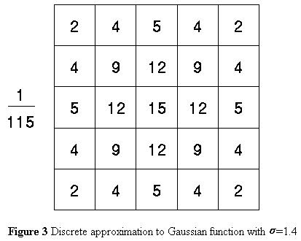
Step 2
After smoothing the image and eliminating the noise, the next step is to find the edge strength by taking the gradient of the image. The Sobel operator performs a 2-D spatial gradient measurement on an image. Then, the approximate absolute gradient magnitude (edge strength) at each point can be found. The Sobel operator uses a pair of 3x3 convolution masks, one estimating the gradient in the x-direction (columns) and the other estimating the gradient in the y-direction (rows). They are shown below:
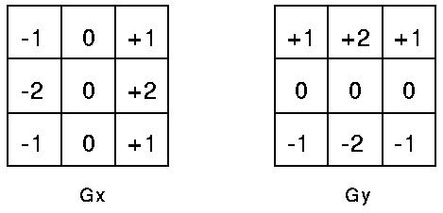
The magnitude, or edge strength, of the gradient is then approximated using the formula:
|G| = |Gx| + |Gy|
Step 3
The direction of the edge is computed using the gradient in the x and y directions. However, an error will be generated when sumX is equal to zero. So in the code there has to be a restriction set whenever this takes place. Whenever the gradient in the x direction is equal to zero, the edge direction has to be equal to 90 degrees or 0 degrees, depending on what the value of the gradient in the y-direction is equal to. If GY has a value of zero, the edge direction will equal 0 degrees. Otherwise the edge direction will equal 90 degrees. The formula for finding the edge direction is just:
Theta = invtan (Gy / Gx)
Step 4
Once the edge direction is known, the next step is to relate the edge direction to a direction that can be traced in an image. So if the pixels of a 5x5 image are aligned as follows:
x x x x x
x x x x x
x x a x x
x x x x x
x x x x x
Then, it can be seen by looking at pixel "a", there are only four possible directions when describing the surrounding pixels - 0 degrees (in the horizontal direction), 45 degrees (along the positive diagonal), 90 degrees (in the vertical direction), or 135 degrees (along the negative diagonal). So now the edge orientation has to be resolved into one of these four directions depending on which direction it is closest to (e.g. if the orientation angle is found to be 3 degrees, make it zero degrees). Think of this as taking a semicircle and dividing it into 5 regions.
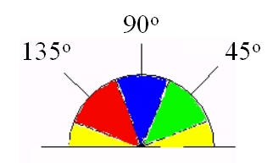
Therefore, any edge direction falling within the yellow range (0 to 22.5 & 157.5 to 180 degrees) is set to 0 degrees. Any edge direction falling in the green range (22.5 to 67.5 degrees) is set to 45 degrees. Any edge direction falling in the blue range (67.5 to 112.5 degrees) is set to 90 degrees. And finally, any edge direction falling within the red range (112.5 to 157.5 degrees) is set to 135 degrees.
Step 5
After the edge directions are known, nonmaximum suppression now has to be applied. Nonmaximum suppression is used to trace along the edge in the edge direction and suppress any pixel value (sets it equal to 0) that is not considered to be an edge. This will give a thin line in the output image.
Step 6
Finally, hysteresis is used as a means of eliminating streaking. Streaking is the breaking up of an edge contour caused by the operator output fluctuating above and below the threshold. If a single threshold, T1 is applied to an image, and an edge has an average strength equal to T1, then due to noise, there will be instances where the edge dips below the threshold. Equally it will also extend above the threshold making an edge look like a dashed line. To avoid this, hysteresis uses 2 thresholds, a high and a low. Any pixel in the image that has a value greater than T1 is presumed to be an edge pixel, and is marked as such immediately. Then, any pixels that are connected to this edge pixel and that have a value greater than T2 are also selected as edge pixels. If you think of following an edge, you need a gradient of T2 to start but you don't stop till you hit a gradient below T1.

Visual Comparison of various edge detection Algorithms



Figure 12: Image used for edge detection analysis (wheel.gif)

Edge detection of all four types was performed on Figure 11 Canny yielded the best results. This was expected as Canny edge detection accounts for regions in an image. Canny yields thin lines for its edges by using non-maximal suppression. Canny also utilizes hysteresis when thresholding.

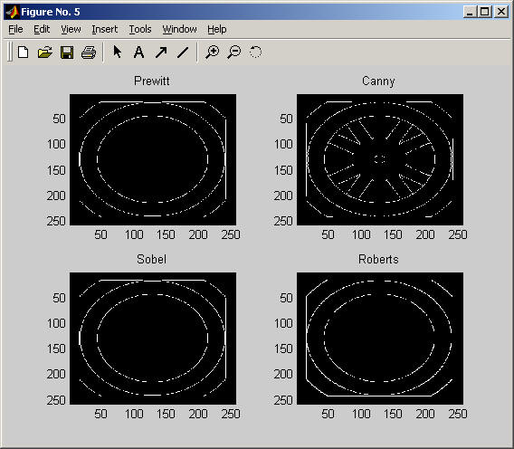

Figure 13: Results of edge detection on Figure 11. Notice Canny had the best results.

Motion blur was applied to Figure 12. Then, the edge detection methods previously used were utilized again on this new image to study their affects in blurry image environments. No method appeared to be useful for real world applications. However, Canny produced the best the results out of the set.

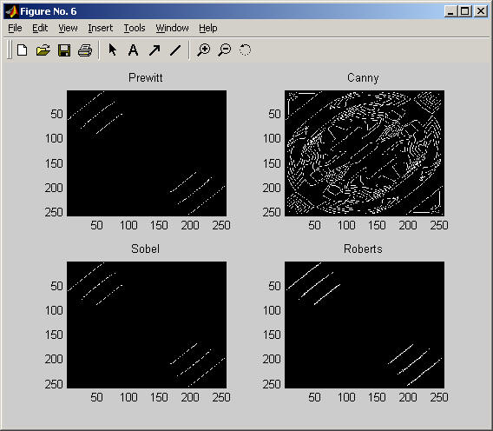

Comparison of Edge detection Algorithm

Original Sobel
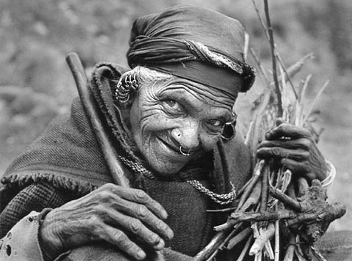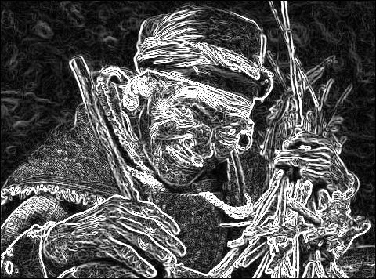

Prewitt Robert
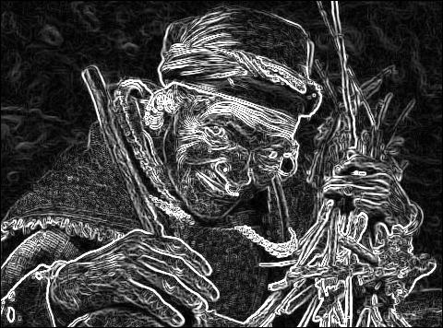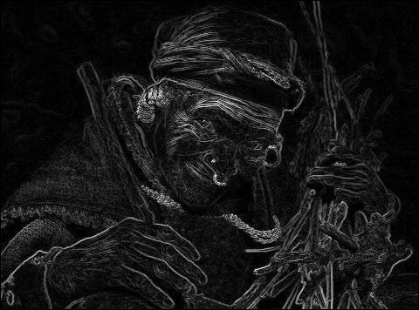

Laplacian Laplacian of Gaussian

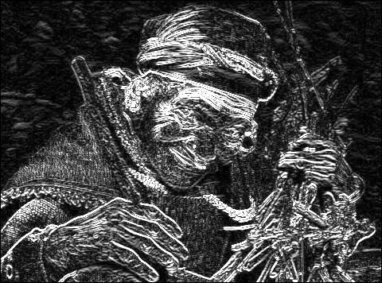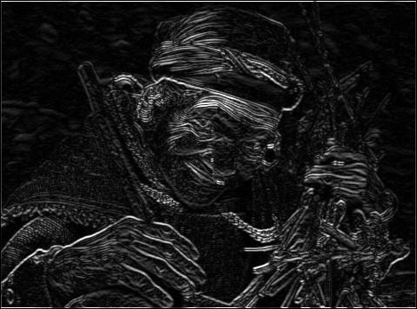

Performance of Edge Detection Algorithms

- Gradient-based algorithms such as the Prewitt filter have a major drawback of being very sensitive to noise. The size of the kernel filter and coefficients are fixed and cannot be adapted to a given image. An adaptive edge-detection algorithm is necessary to provide a robust solution that is adaptable to the varying noise levels. Gradient-based algorithms such as the Prewitt filter have a major drawback of being very sensitive to noise. The size of the kernel filter and coefficients are fixed and cannot be adapted to a given image. An adaptive edge-detection algorithm is necessary to provide a robust solution that is adaptable to the varying noise levels of these images to help distinguish valid image contents from visual artifacts introduced by noise.

- The performance of the Canny algorithm depends heavily on the adjustable parameters, σ, which is the standard deviation for the Gaussian filter, and the threshold values, ‘T1’ and ‘T2’. σ also controls the size of the Gaussian filter. The bigger the value for σ, the larger the size of the Gaussian filter becomes. This implies more blurring, necessary for noisy images, as well as detecting larger edges. As expected, however, the larger the scale of the Gaussian, the less accurate is the localization of the edge. Smaller values of σ imply a smaller Gaussian filter which limits the amount of blurring, maintaining finer edges in the image. The user can tailor the algorithm by adjusting these parameters to adapt to different environments.

- Canny’s edge detection algorithm is computationally more expensive compared to Sobel, Prewitt and Robert’s operator. However, the Canny’s edge detection algorithm performs better than all these operators under almost all scenarios.

References:

RC Gonzalez and RE Woods, Prentice-Hall, 2002

http://zone.ni.com/devzone/conceptd.nsf/webmain/37BF3B76F646EF5286256802007BA00F

http://www.pages.drexel.edu/~weg22/edge.html

http://people.westminstercollege.edu/students/djb0331/CMPT300/Project/ProjectDiscussion.htm

http://homepages.inf.ed.ac.uk/rbf/HIPR2/log.htm

http://www.redbrick.dcu.ie/~bolsh/thesis/node30.html

http://www.pages.drexel.edu/~weg22/can_tut.html

http://www.personal.psu.edu/users/b/r/brv106/cse485/project2.htm

http://www.altera.com/literature/cp/gspx/edge-detection.pdf

